**STORYVERSE APP**

***An project report submitted in partial fulfillment of the requirement for the Award of the Degree of***

### BACHELOR OF ENGINEERING

**in**

### COMPUTER SCIENCE AND ENGINEERING

***by***

**MUSTAFA MOHAMMED MERAJ (160722733076)**

**MIR AYAN ALI (160722733083)**

**AYMAN UZAYR (160722733086)**

***Under the Guidance of***

**Mr. T. Srikara Shobith Assistant Professor, Dept. of CSE**

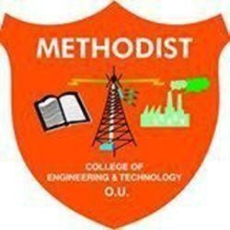

**Department of Computer Science and Engineering Methodist College of Engineering and Technology, King Koti, Abids, Hyderabad-500001.**

**2024-2025**

1



## King Koti, Abids, Hyderabad-500001,

### VISION

To produce ethical, socially conscious and innovative professionals who would contribute to sustainable technological development of the society.

### MISSION

To impart quality engineering education with latest technological developments and interdisciplinary skills to make students succeed in professional practice.

To encourage research culture among faculty and students by establishing state of art laboratories and exposing them to modern industrial and organizational practices.

To inculcate humane qualities like environmental consciousness, leadership, social values, professional ethics and engage in independent and lifelong learning for sustainable contribution to the society.



## King Koti, Abids, Hyderabad-500001,

DEPARTMENT OF COMPUTER SCIENCE AND ENGINEERING

### VISION

To become a leader in providing Computer Science and Engineering education with emphasis on knowledge and innovation.

### MISSION

* To offer flexible programs of study with collaborations to suit industry needs.
* To provide quality education and training through novel pedagogical practices.
* To expedite high performance of excellence in teaching, research and innovations.
* To impart moral, ethical values and education with social responsibility.

Head of the Department Department of CSE

Methodist College of Engineering & Technology

Abids, Hyderabad



## King Koti, Abids, Hyderabad-500001,

DEPARTMENT OF COMPUTER SCIENCE AND TECHNOLOGY

**Program Outcomes**

**PO1. Engineering knowledge:** Apply the knowledge of mathematics, science, engineering fundamentals, and an engineering specialization to the solution of complex engineering problems.

**PO2. Problem analysis:** Identify, formulate, review research literature, and analyze complex engineering problems reaching substantiated conclusions using first principles of mathematics, natural sciences, and engineering sciences.

**PO3. Design/development of solutions:** Design solutions for complex engineering problems and design system components or processes that meet the specified needs with appropriate consideration for the public health and safety, and the cultural, societal, and environmental considerations.

**PO4. Conduct investigations of complex problems:** Use research-based knowledge and research methods including design of experiments, analysis and interpretation of data, and synthesis of the information to provide valid conclusions.

**PO5. Modern tool usage:** Create, select, and apply appropriate techniques, resources, and modern engineering and IT tools including prediction and modeling to complex engineering activities with an understanding of the limitations.

**PO6. The engineer and society:** Apply reasoning informed by the contextual knowledge to assess societal, health, safety, legal and cultural issues and the consequent responsibilities relevant to the professional engineering practice.

**PO7. Environment and sustainability:** Understand the impact of the professional engineering solutions in societal and environmental contexts, and demonstrate the knowledge of, and need for sustainable development.

**PO8. Ethics:** Apply ethical principles and commit to professional ethics and responsibilities and norms of the engineering practice.

**PO9. Individual and teamwork:** Function effectively as an individual, and as a member or leader in diverse teams, and in multidisciplinary settings.

**PO10. Communication:** Communicate effectively on complex engineering activities with the engineering community and with society at large, such as, being able to comprehend and write effective reports and design documentation, make effective presentations, and give and receive clear instructions.

**PO11. Project management and finance:** Demonstrate knowledge and understanding of the engineering and management principles and apply these to one’s own work, as a member and leader in a team, to manage projects and in multidisciplinary environments.

**PO12. Life-long learning:** Recognize the need for and have the preparation and ability to engage in independent and life-long learning in the broadest context of technological change.



## King Koti, Abids, Hyderabad-500001,

### PROGRAM EDUCATIONAL OBJECTIVES

**At the end of 4 years, Compute Science and Engineering graduates at MCET will be able to: PSO1:** Apply the knowledge of Computer Science and Engineering in various domains like networking and data mining to manage projects in multidisciplinary environments.

**PSO2:** Develop software applications with open-ended programming environments.

**PSO3:** Design and develop solutions by following standard software engineering principles and implement by using suitable programming languages and platforms.



## King Koti, Abids, Hyderabad-500001,

**Department of Computer Science and Engineering**

**Skill Development Course-III – Mobile Application Development (3PW560CS)**

### A.Y 2024-2025

This is to certify that this SDC-III (Mobile Application Development) report entitled

“**STORYVERSE APP”,** being submitted *by* **“**MUSTAFA MOHAMMED MERAJ (160722733076)”, “MIR AYAN ALI (160722733083)” and **“**AYMAN UZAYR (160722733086)”, submitted in partial fulfillment of the requirements for the degree of Bachelor of Engineering in Computer Science, during the academic year 2024-2025, is a bonafide record of work carried out by them.

**INTERNAL EXTERNAL HOD**



## King Koti, Abids, Hyderabad-500001,

**Department of Computer Science and Engineering**



### DECLARATION BY THE CANDIDATES

We, MUSTAFA MOHAMMED MERAJ (160722733076), MIR AYAN ALI (160722733083) and AYMAN UZAYR (160722733086) students of Methodist College of Engineering and Technology, pursuing Bachelor’s degree in Computer Science and Engineering, hereby declare that SDC-III (Mobile Application Development) report entitled “STORYVERSE APP”, carried out under the guidance of Mr. T. Srikara Shobith submitted in partial fulfillment of the requirements for the degree of Bachelor of Engineering in Computer Science. This work is carried out by us and the references have been taking from various digital resources for report preparation.

**MUSTAFA MOHAMMED MERAJ (160722733076)**

**MIR AYAN ALI (160722733083)**

**AYMAN UZAYR (160722733086)**



## King Koti, Abids, Hyderabad-500001,

**Department of Computer Science and Engineering**



### CERTIFICATE BY THE SDC III (MOBILE APPLICATION DEVELOPMENT) LAB INCHARGE

This is to certify that this SDC-III (Mobile Application Development) report entitled “**STORYVERSE APP”,** being submitted *by* **MUSTAFA MOHAMMED MERAJ (160722733076), MIR AYAN ALI (160722733083)** and **AYMAN UZAYR (160722733086),** submitted in partial fulfillment of the requirements for the degree of Bachelor of Engineering in Computer Science, during the academic year 2024-2025, is a bonafide record of work carried out by them.

#### Mr. T. Srikara Shobith

Assistant Professor,

Dept. of CSE



## King Koti, Abids, Hyderabad-500001,

**Department of Computer Science and Engineering**



**CERTIFICATE BY THE HEAD OF THE DEPARTMENT**

This is to certify that this SDC-III (Mobile Application) report entitled “**STORYVERSE APP**” *by* MUSTAFA MOHAMMED MERAJ (160722733076), MIR AYAN ALI (160722733083) and

AYMAN UZAYR (160722733086), submitted in partial fulfillment of the requirements for the degree of Bachelor of Engineering in Computer Science of the Osmania University, Hyderabad, during the academic year 2024-2025, is a bonafide record of work carried out by them.

#### Dr. Lavanya Pamulaparty,

Professor & Head of the Department

**ACKNOWLEDGEMENT**

We would like to express a deep sense of gratitude towards the **Dr. Lakshmipathi Rao, Director, Methodist College of Engineering and Technology,** for always being an inspiration and for always encouraging us in every possible way.

We would like to express a deep sense of gratitude towards the **Dr. Prabhu G Benakop, Principal, Methodist College of Engineering and Technology,** for always being an inspiration and for always encouraging us in every possible way.

Our sincere thanks to **Dr. P. Lavanya, Professor** and **Head of the Department of Computer Science and Engineering,** for her valuable guidance and encouragement which has played a major role in the completion of the project and for helping us by being an example of high vision and pushing towards greater limits of achievement.

We would like to express our sincere gratitude to our project guide **Mr. T. Srikara Shobith, Assistant Professor,** for giving us the opportunity to work on this topic. It would never be possible for us to take this project to this level without his innovative ideas and his relentless support and encouragement. Who helped us by being an example of high vision and pushing towards greater limits of achievement.

We are indebted to the Department of Computer Science & Engineering and Methodist College of Engineering and Technology for providing us with all the required facility to carry our work in a congenial environment. We extend our gratitude to the CSE Department staff for providing us to the needful time to time whenever requested.

We would like to thank our parents for allowing us to realize our potential, all the support they have provided us over the years was the greatest gift anyone has ever given us and also for teaching us the value of hard work and education. Our parents have offered us tremendous support and encouragement, thanks to our parents for all the moral support and the amazing opportunities they have given us over the years.

10

# TABLE OF CONTENTS:

1. **Abstract** Pg. no. 12
2. **Introduction** Pg. no. 13
3. **Literature Survey** Pg. no. 14
4. **Proposed System** Pg. no. 15
   1. Objectives
   2. Key Feature
5. **System Study** Pg. no. 19
   1. Operational Feasibility
   2. Economic Feasibility
   3. Technical Feasibility
6. **Software Requirements** Pg. no. 27
7. **Hardware Requirements** Pg. no. 29
8. **System Architecture** Pg. no. 30
   1. Architecture Overview
   2. Key Components
   3. Data Flow Diagram
9. **Graphical User Interface** Pg. no. 35
   1. Splash Screen
   2. Home Screen
   3. Genre Selection Screen
   4. Recommendation Screen
   5. Movie Detail Screen
10. **Test Cases** Pg. no. 40
11. **Conclusion** Pg. no. 46
12. **Future Improvisations** Pg. no. 47
13. **References** Pg. no. 49

# ABSTRACT

StoryVerse is an innovative application designed to provide personalized entertainment recommendations by allowing users to explore books or movies based on their preferred genres. With a sleek and intuitive multi-page interface, the app enables users to select their desired medium (books or movies), choose genres, and even combine two genres to receive tailored suggestions. The platform delivers detailed recommendations enriched with insightful descriptions to help users make informed choices.

The app’s architecture is built using modern web technologies, ensuring a seamless and responsive user experience. Core components include a dynamic home screen, a genre selection interface, a detail screen for in-depth exploration, and a dedicated settings page for personalization. Each screen is supported by well-structured and reusable styles to maintain design consistency.

StoryVerse leverages carefully curated datasets and integrates visually engaging assets to enhance user interaction. Its modular design allows for scalability, enabling future enhancements such as user reviews, social sharing, or advanced recommendation algorithms. By bridging the gap between user preferences and content discovery, StoryVerse aims to redefine how individuals engage with entertainment.

With its unique genre-mixing feature and user-centric design, StoryVerse is a compelling solution for anyone seeking customized entertainment experiences.

# INTRODUCTION

In an era dominated by an abundance of entertainment options, finding the perfect book or movie to suit personal preferences can be overwhelming. StoryVerse is here to simplify that journey. This app leverages cutting-edge technology and user-focused design to offer a seamless and enjoyable content discovery experience. By prioritizing personalization and user engagement, StoryVerse aims to transform how individuals explore and consume entertainment.

The app’s central premise revolves around its ability to recommend books or movies tailored to the user’s interests. Unlike conventional platforms, StoryVerse introduces a unique feature that allows users to mix two genres, enabling them to discover unconventional and exciting content. The app’s intuitive interface and thoughtfully designed features ensure ease of use for individuals of all age groups.

StoryVerse also stands out for its modular and scalable architecture, making it adaptable to future trends and user demands. With the potential for integrating advanced recommendation algorithms, social sharing options, and community-driven reviews, StoryVerse is poised to grow into a comprehensive entertainment companion.

This document explores the core functionalities, design philosophy, and technical framework of StoryVerse, showcasing its role as a trailblazer in personalized entertainment discovery.

# LITERATURE SURVEY

Story Verse connects to interactive storytelling, narrative generation, and Large Language Model (LLM)-based character simulation. A research publication titled "StoryVerse: Towards Co-authoring Dynamic Plot with LLM-based Character Simulation via Narrative Planning" explores using AI to balance authorial intent and emergent character behaviors. It describes creating dynamic plots for gaming environments by defining flexible plot outlines and using LLMs for character simulation. Similarly, platforms like Storyverse.xyz integrate storytelling with NFTs, enabling users to create and share animated narratives.

StoryVerse and similar projects show potential in interactive storytelling, blending authorial intent with dynamic simulations for immersive and evolving stories. These systems allow personalized narratives that adapt to player interactions, enhancing engagement. They also serve as tools for creators to design and share interactive stories, possibly integrating NFTs for monetization.

Challenges in this domain include balancing structured narrative coherence with emergent, player-driven storylines. StoryVerse represents an exciting intersection of AI-driven narratives, interactive storytelling, and creative technology. Future work should focus on exploring applications further and addressing these challenges.

# PROPOSED SYSTEM

The proposed system, **StoryVerse**, is a mobile application designed to provide users with personalized book and movie recommendations based on their preferred genres. It enables users to mix genres for a unique and tailored experience, offering a seamless platform to explore and discover content that matches their interests. The app serves as an all-in-one solution for users looking for relevant recommendations, ensuring that their entertainment needs are always met, regardless of the genre or medium.

## Objectives

1. **Personalized Recommendations**: Ensure users receive content suggestions based on their specific tastes and preferences, considering their chosen genres.
2. **Enhanced Discovery**: Provide a platform where users can mix two or more genres for more diverse and tailored recommendations.
3. **Intuitive Interface**: Develop an easy-to-use interface that allows users to quickly navigate through options and discover new content with minimal effort.
4. **Seamless Experience**: Create a frictionless journey for users to explore books and movies, with quick genre selection and efficient recommendation delivery.
5. **Cater to Diverse Interests**: Offer recommendations for both books and movies, ensuring the app meets the needs of a broad audience.
6. **User Engagement**: Foster a sense of connection with users through a personalized, relevant content experience, encouraging them to explore new genres and discover content they may have missed.

## Key Features:

1. **Personalized Genre-Based Recommendations**:

* A recommendation engine that suggests books and movies based on users' selected genres and preferences.
* The ability to mix genres for more diverse recommendations tailored to the user’s unique tastes.

1. **User-Friendly Genre Selection**:

* Simple and intuitive genre selection process to help users quickly choose from a wide range of options.
* Quick genre switcher for users who wish to explore new genres or find different combinations of genres for recommendations.

1. **Detailed Recommendations**:

* For each book or movie suggestion, provide detailed information such as synopsis, ratings, and related content.
* Links to external platforms for easy access to the content (e.g., streaming services or online bookstores).

1. **Multi-Genre Recommendation Engine**:

* A feature that allows users to blend genres, e.g., “action + romance” or “mystery + fantasy,” to receive curated content suggestions based on these combinations.

1. **Easy-to-Navigate Interface**:

* Minimalist design for efficient navigation and content discovery.
* Clear categorization of books and movies, ensuring users can quickly find what they’re looking for.

1. **User Feedback and Ratings**:

* Option for users to rate and review books and movies, contributing to the overall recommendation system.
* Display user ratings and reviews to help others make informed choices.

1. **Search and Filter Functionality**:

* Advanced search options to help users find specific books or movies based on keywords, genres, and other criteria.
* Filtering options that allow users to narrow down recommendations based on factors like ratings, release date, or popularity.

1. **Cross-Platform Compatibility**:

* The app will be available on both Android and iOS, ensuring accessibility to a wide range of users.
* Seamless integration with external platforms for accessing content directly (e.g., Netflix, Amazon Books).

# SYSTEM STUDY

## Feasibility Study for StoryVerse:

This analysis evaluates the practicality of developing and deploying the StoryVerse app by considering operational, economic, and technical factors.

## Operational Feasibility

**Objective** : Assess the practicality and ease of implementing and maintaining the app in real-world scenarios.

* **User Adoption Potential**:  
  Given the growing interest in personalized entertainment, StoryVerse is positioned to attract a diverse user base. The app’s simple, user-friendly interface ensures that both tech-savvy and non-technical users can easily navigate through the platform and receive customized recommendations based on their genre preferences.
* **Content Integration**:  
  StoryVerse can seamlessly integrate with third-party content providers, such as movie streaming services and digital bookstores, through established APIs like TMDB (for movies) and Google Books API. This provides users with direct access to content suggested by the app without navigating multiple platforms.
* **Scalability**:  
  As user numbers and content offerings grow, StoryVerse is designed to scale effectively. The platform is built to accommodate the addition of new genres, content providers, and regional preferences, ensuring the app continues to meet users’ evolving needs.
* **Sustained Support and Upkeep**:  
  Ongoing updates and maintenance can be managed efficiently, with periodic updates based on user feedback. This ensures the app remains aligned with user expectations and incorporates new features over time, promoting a positive long-term experience.

**Conclusion**: The system is operationally feasible, offering an efficient, scalable solution for personalized recommendations with a clear plan for user engagement and content expansion.

## Economic Feasibility

**Objective**: Analyze the financial viability and long-term sustainability of the project.

* **Initial Development Costs**:  
  The development costs for StoryVerse include design, development, testing, and deployment. By leveraging cross-platform development tools such as React Native, the project minimizes upfront costs. Additionally, using existing APIs to source content reduces the need for custom infrastructure, further cutting down development expenses.
* **Monetization Strategies**:  
  Several potential revenue streams exist for StoryVerse:
  + **Premium Subscriptions**: Users can opt for premium memberships to unlock enhanced features, such as personalized recommendations, exclusive content, or an ad-free experience.
  + **Affiliate Partnerships**: The app can partner with content providers, earning a commission for every user who accesses or purchases content through StoryVerse’s recommendations.
  + **Advertising**: Non-intrusive, targeted advertising related to entertainment services can provide an additional revenue stream while ensuring user experience remains unaffected.
* **Ongoing Maintenance and Operational Costs**:  
  The recurring costs for hosting, API access, and customer support are expected to be manageable. With efficient infrastructure, the app can operate with minimal ongoing costs, ensuring long-term financial sustainability.

**Conclusion**: The project is economically feasible, offering a sound financial plan with multiple monetization strategies. With manageable development and operational costs, StoryVerse is well-positioned for sustained profitability.

## Technical Feasibility

**Objective**: Assess the technical aspects of developing, deploying, and maintaining the StoryVerse app.

* **Technology Stack**:  
  StoryVerse will be built using a modern and reliable technology stack. The app will be developed with **React Native**, enabling cross-platform compatibility for both iOS and Android users. This ensures the app reaches a wide audience while minimizing development time and cost.
* **Third-Party API Integration**:  
  The app will integrate with content provider APIs such as the **TMDB (The Movie Database)** for movie recommendations and the **Google Books API** for book suggestions. These APIs are well-documented, stable, and widely used, ensuring reliable access to content and easy integration into the app.
* **Database and Backend Infrastructure**:  
  StoryVerse will rely on **cloud-based databases** (e.g., Firebase or AWS) to store user data, preferences, and activity history. Cloud storage ensures scalability and easy management of large amounts of data, enabling real-time updates and a seamless experience. The backend will support user authentication, recommendation algorithms, and content management.
* **Recommendation Algorithm**:  
  The app will incorporate a sophisticated recommendation engine powered by machine learning algorithms to analyze user behavior and preferences. This system will continuously improve as users interact with the app, allowing StoryVerse to provide highly personalized content suggestions. The algorithms will process data from users' interaction history, ratings, and preferences to deliver relevant recommendations.
* **Security and Privacy**:  
  The app will prioritize user security and data privacy, complying with industry standards such as **GDPR** (General Data Protection Regulation) and other local data protection laws. Secure encryption protocols will be implemented for user data, ensuring privacy and protection against unauthorized access.
* **Performance and Scalability**:  
  The app will be optimized for fast loading times and smooth performance across devices. The use of **cloud services** ensures scalability, allowing the app to handle growing user numbers without compromising performance. As StoryVerse expands, additional resources can be allocated on-demand to maintain system performance.
* **Testing and Quality Assurance**:  
  Rigorous testing procedures will be followed during the development phase, including **unit testing**, **integration testing**, and **user acceptance testing**. Automated testing tools and frameworks will be used to ensure high-quality code and the app’s stability across multiple platforms.

**Conclusion**:  
The technical feasibility of StoryVerse is strong, leveraging reliable, modern technologies for app development, content integration, and database management. The system is designed to scale, ensuring optimal performance as the user base grows. With a focus on security, machine learning, and real-time updates, StoryVerse provides a technically robust platform for personalized entertainment recommendations.

## Overall Feasibility Assessment:

**Objective**:

Provide a comprehensive evaluation of the project's viability by integrating insights from the operational, economic, and technical feasibility analyses.

* **Operational Feasibility**:  
  StoryVerse is designed to provide a seamless and intuitive user experience. The app’s user-friendly interface and integration with third-party content APIs make it highly accessible to a broad audience. Its scalable architecture ensures that as the app grows, both in terms of users and content offerings, it can expand without compromising performance or user satisfaction. Regular updates and feedback loops will enable continuous improvement and adaptation to user needs.
* **Economic Feasibility**:  
  The project presents a promising economic outlook. The initial development costs are manageable, and multiple revenue generation strategies such as premium subscriptions, affiliate partnerships, and in-app advertisements provide a diverse financial base. The app’s design ensures low ongoing operational costs, primarily related to cloud services, API access, and maintenance, making it financially sustainable. With a solid monetization plan, StoryVerse has the potential to generate substantial revenue while maintaining a user-centric approach.
* **Technical Feasibility**:  
  The technical foundation for StoryVerse is robust. By using **React Native** for cross-platform development, the app ensures broad compatibility across both iOS and Android platforms. The integration with established APIs and the use of cloud-based infrastructure for storage and backend operations guarantee a stable, scalable, and secure system. Additionally, the recommendation engine powered by machine learning enhances the personalization of user experiences, making the app more engaging. The app is designed with security and privacy in mind, complying with industry standards and ensuring user data protection.

**Conclusion**:  
After analyzing the operational, economic, and technical aspects of the StoryVerse app, it is clear that the project is highly feasible. The app is positioned to offer a valuable service with a strong potential for success in the market. It combines a user-friendly interface, solid monetization strategies, and modern technology to deliver personalized content recommendations effectively. The system is scalable, secure, and financially sustainable, ensuring its long-term viability in a competitive entertainment market.

# SOFTWARE REQUIREMENTS

1. **Development Environment:**
2. **Development IDE**: Android Studio
3. **React Native Version**: 0.71.0 (or latest stable release)
4. **Node.js Version**: 18.x.x (LTS)
5. **NPM Version**: 9.x.x
6. **Expo Version**: 48.0.0
7. **Xcode Version**: 14.x (for iOS build)
8. **Android Studio Version**: Arctic Fox | 2021.3.1 Patch 3
9. **Gradle Plugin Version**: 7.4
10. **Java Version**: OpenJDK 17
11. **Libraries and Dependencies**:
12. **React Navigation**: 6.1.0 (for navigation between screens)
13. **Axios**: 0.27.2 (for making HTTP requests)
14. **React Query**: 3.39.2 (for data fetching and caching)
15. **React Native Gesture Handler**: 2.10.0 (for gesture-based interactions)
16. **React Native Paper**: 4.12.0 (for UI components and Material Design)
17. **Lottie for React Native**: 5.1.1 (for animations)
18. **Testing Libraries:**
19. **Jest**: 29.0.1 (for unit testing)
20. **React Testing Library**: 13.4.0 (for React component testing)
21. **Detox**: 19.0.0 (for end-to-end testing)
22. **Support Libraries**:
23. **React Native Vector Icons**: 9.1.0 (for icons)
24. **React Native Async Storage**: 1.15.0 (for persistent storage)
25. **APIs and Services**:
26. **TMDB API**: To fetch movie data, including movie details, ratings, and genres. Used for recommending movies based on user input.
27. **Google Books API**: To retrieve book data, including authors, titles, summaries, and genres. Supports recommendations based on user genre preferences.
28. **Firebase Authentication**: For user authentication, allowing secure login and registration.
29. **Firebase Cloud Firestore**: For real-time database management, storing user preferences and recommendation history.
30. **Firebase Cloud Messaging**: For sending notifications to users about new recommendations or app updates.
31. **Additional Tools**:
32. **Git**: Version control using Git and GitHub for code management and collaboration.

# HARDWARE REQUIREMENTS

1. **Minimum Hardware Specifications**:
2. **Android Device or Emulator**
3. **Operating System**: Android 5.0 (Lollipop) and above
4. **Processor**: Dual-core 1.2GHz or equivalent
5. **RAM**: 2GB or higher
6. **Storage**: 50MB of available space
7. **Network**: Wi-Fi or Cellular connectivity for accessing content and recommendations
8. **Recommended Hardware Specifications**:
9. **Android Device with Higher Processing Power**
10. **Operating System**: Android 8.0 (Oreo) and above
11. **Processor**: Quad-core 1.8GHz or equivalent
12. **RAM**: 4GB or higher for a smoother experience
13. **Storage**: 100MB of available space
14. **Network**: Wi-Fi connection recommended for faster content loading and seamless recommendations

# SYSTEM ARCHITECTURE

The system architecture for *StoryVerse* follows a modular, multi-tiered design to ensure scalability, reliability, and maintainability. It includes key components such as the user interface, backend services, databases, and third-party integrations.

## Architecture Overview :

#### ****Components:****

1. **Mobile App (Frontend Layer)**
   * **Description**: This is the user-facing component developed using **Android Studio** with **Java** and **XML** for designing the user interface. The mobile app provides the primary interaction for users to explore book and movie recommendations.
   * **Main Functions**:
     + Genre selection and recommendation requests
     + Display of book and movie recommendations based on selected genres
     + Communication with the server to fetch and update data
   * **Technologies**:
     + Android Studio, Java, XML
2. **Application Server (Backend Layer)**
   * **Description**: The backend handles the business logic, processes requests from the mobile app, and manages the interaction with databases and external APIs.
   * **Main Functions**:
     + Processing user requests for book and movie recommendations
     + Handling genre-based recommendation logic
     + Fetching data from external APIs (e.g., TMDB API for movies, Google Books API for books)
     + Managing user preferences and storing recommendation data
   * **Technologies**:
     + **Node.js** or **Java Spring Boot**
     + **RESTful APIs** for communication with the mobile app
3. **Database Management System (Data Layer)**
   * **Description**: Stores and manages all data related to users, recommendations, preferences, and external API data.
   * **Main Functions**:
     + Storing user preferences and recommendation history
     + Saving movie and book details fetched from external APIs
   * **Technologies**:
     + **Firebase Firestore** for real-time database features (optional)
     + **MySQL/PostgreSQL** for structured storage
4. **Third-Party Services (External Integration Layer)**
   * **Description**: Integrates with external services to enhance functionality and provide necessary content to the users.
   * **Main Integrations**:
     + **TMDB API** for movie data (titles, ratings, genres)
     + **Google Books API** for book data (titles, authors, summaries)
   * **Technologies**:
     + **TMDB API** for movie-related content
     + **Google Books API** for book-related content

## DATA FLOW DIAGRAM

1. **User Interaction**:
   * Users interact with the mobile app, select genres, and request recommendations.
2. **Data Fetching**:
   * The app communicates with the backend to process the requests and fetch relevant recommendations.
3. **External API Integration**:
   * The backend retrieves movie and book data from the external APIs (TMDB for movies, Google Books for books).
4. **Database Storage**:
   * The backend stores user preferences and recommendation history in the database.
5. **Display to User**:
   * The mobile app displays the fetched data (book/movie recommendations) to the user.

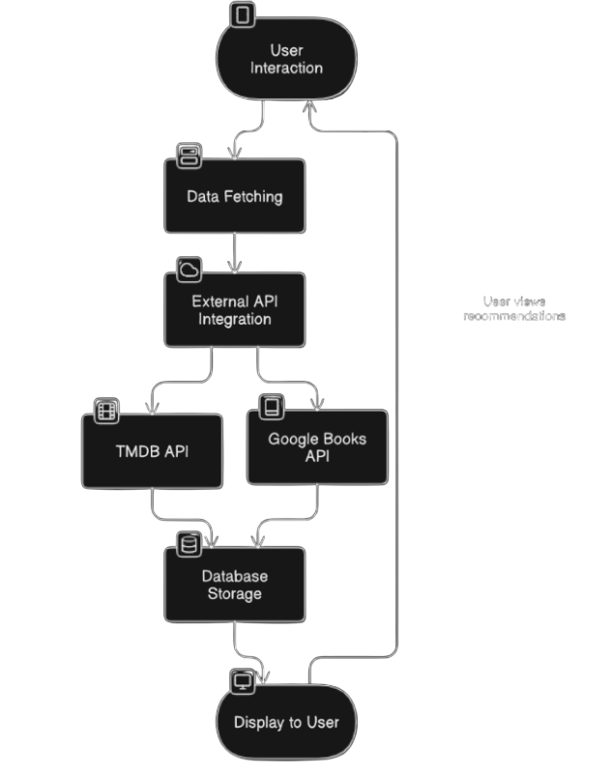

# GRAPHICAL USER INTERFACE

* + **Splash Screen**

The below is an image showcasing the splash screen of the StoryVerse application. It creates a captivating first impression and serves as a visual introduction to the platform's vast library of books and movies.

**Key Features Visible:**

1. **Background:** A dark, moody background with a subtle texture, creating a sense of mystery and intrigue.
2. **Book and Movie Covers:** A collage of diverse and iconic book and movie covers fills the screen, showcasing the breadth of content available on StoryVerse.
3. **Logo:** The StoryVerse logo is prominently displayed in a bold, modern font, establishing the brand identity.
4. **Tagline:** The tagline "Enjoy the gathering of all books and movies" is positioned below the logo, emphasizing the platform's comprehensive collection and inviting users to explore.
5. **"Skip" Button:** A prominent orange "Skip" button is placed at the bottom of the screen, allowing users to bypass the splash screen and access the main application.

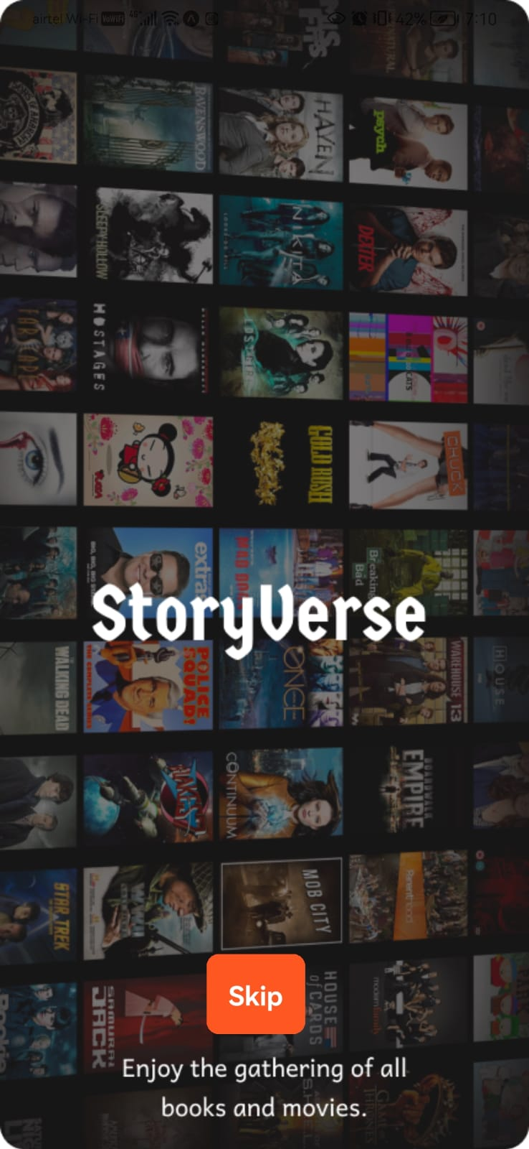

* + **Home Screen**

This below is an image showcasing the home screen of the StoryVerse application. It presents users with the initial choice of content type and sets the stage for their exploration of the platform's extensive library.

**Key Features Visible:**

1. **Background:** A dramatic, dark red background with a dynamic cloud-like pattern, creating a sense of mystery and intrigue.
2. **Silhouette:** A silhouette of a person standing against the background, suggesting exploration and discovery.
3. **Heading:** "Find Your Next Favorite!" is displayed prominently, emphasizing the platform's goal of helping users find new content they'll love.
4. **Buttons:** Three large, rounded buttons are displayed: "Movies," "TV Shows," and "Books," inviting users to select their preferred content type and proceed to the corresponding section of the application.
5. 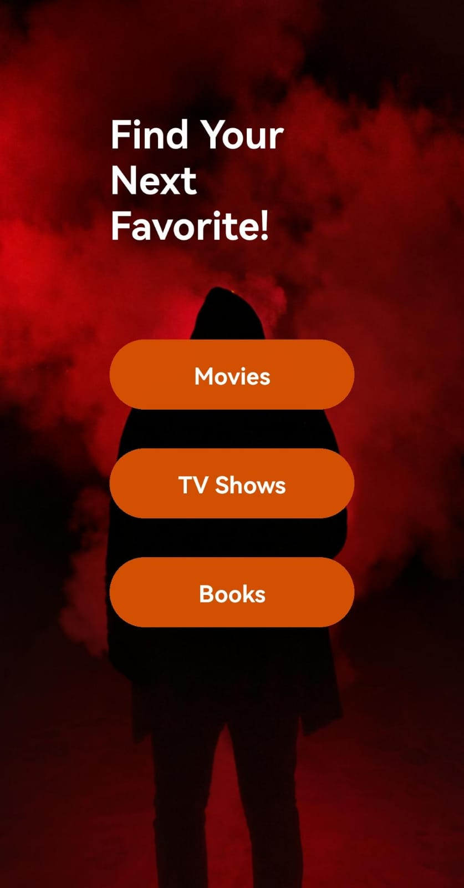**Color Scheme:** A bold contrast between the dark red background and the orange buttons creates a visually striking and memorable impression. This flow creates a smooth user experience, guiding them from the initial selection of a service to detailed, actionable information with just a few taps.
   * **Genre Selection Screen**

This screen allows users to customize their content recommendations by selecting their preferred movie genres.

**Key Features Visible:**

1. **Heading:** "Select Genres for Movies" is displayed at the top, clearly indicating the purpose of the screen.
2. **Genre Buttons:** A grid of genre buttons is presented, covering a wide range of movie genres, including Action, Adventure, Animation, Comedy, Crime, Documentary, Drama, Family, Fantasy, History, Horror, Music, Mystery, Romance, Science Fiction, TV Movie, Thriller, War, and Western.
3. **"Get Recommendations" Button:** A prominent orange button at the bottom allows users to submit their selected genres and receive personalized recommendations.

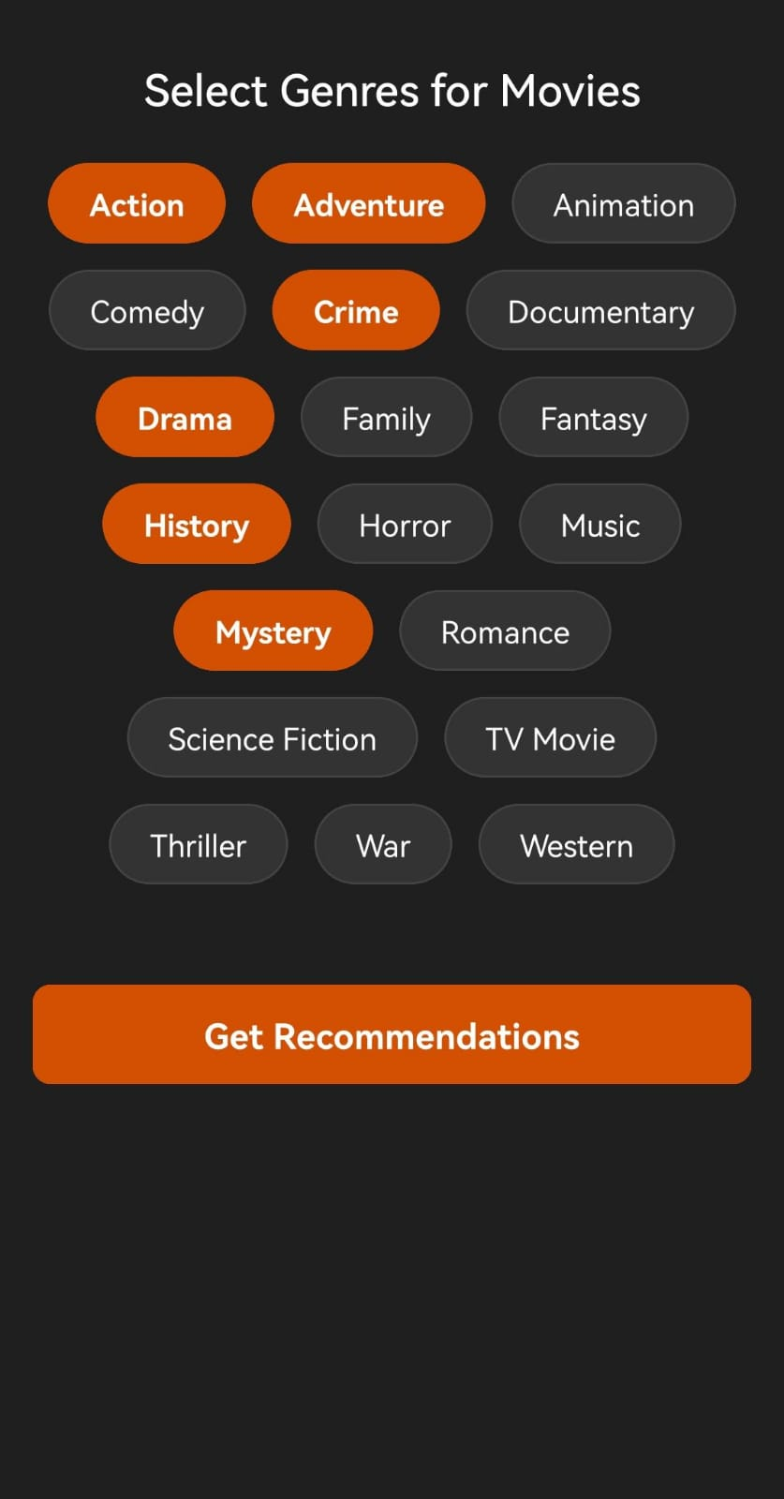

* + **Recommendation Screen**

This screen displays a curated list of movie recommendations based on the user's selected genres.

**Key Features Visible:**

1. **Heading:** "Recommendations" is displayed at the top, clearly indicating the purpose of the screen.
2. **Movie Posters:** A grid of movie posters is presented, showcasing recommended movies based on the user's genre selections.
3. **Movie Titles:** Below each poster, the corresponding movie title is displayed.
4. **Pagination:** "Page 1 of 65" indicates the current page and the total number of pages with recommendations.
5. **Navigation Arrows:** Left and right arrows at the bottom allow users to navigate through the pages of recommendations.

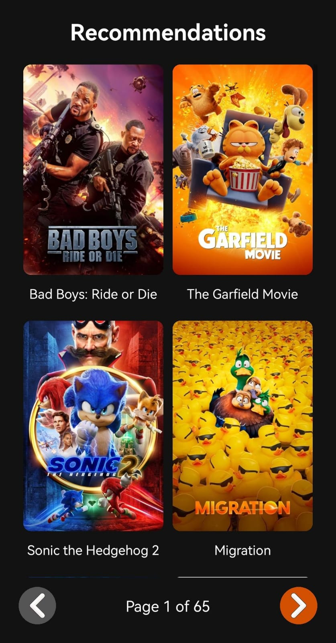

* + **Movie Details Screen**

This screen displays detailed information about a specific movie when the user clicks on a movie poster on the Recommendations screen.

**Key Features Visible:**

1. **Movie Poster:** A large, high-quality image of the movie poster is prominently displayed.
2. **Movie Title:** The full title of the movie is displayed in a clear and prominent font.
3. **Rating:** The movie's rating (e.g., 7.5/10) is displayed, providing users with an initial assessment of its quality.
4. **Release Date:** The movie's release date is displayed, giving users context about the film's recency.
5. **Genres:** A list of the movie's genres is displayed, allowing users to quickly identify the type of film it is.
6. **Overview:** A brief synopsis or overview of the movie's plot is provided, giving users a taste of the story.
7. **Cast:** A list of the main cast members is displayed, allowing users to see which actors are featured in the film.

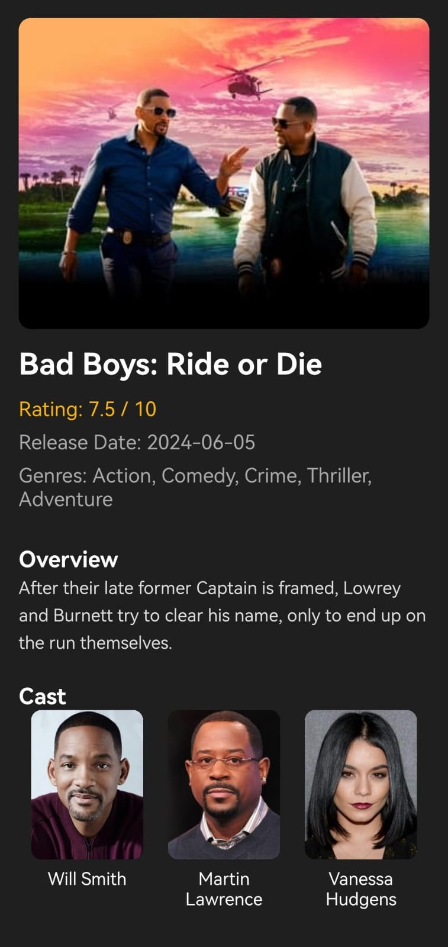

### ****TESTING CASES****

### ****Genre Selection and Recommendation****

**Test Case 1.1: Genre Selection**

* **Objective**: Verify that users can select a genre for recommendations.
* **Steps**:
  1. Open the app.
  2. Navigate to the genre selection screen.
  3. Choose a genre (e.g., Fantasy, Thriller).
* **Expected Result**: The app displays the selected genre and shows the appropriate options for books or movies.

**Test Case 1.2: No Genre Selected**

* **Objective**: Ensure the app handles the case where no genre is selected.
* **Steps**:
  1. Open the app.
  2. Skip genre selection and try to get recommendations.
* **Expected Result**: The app prompts the user to select a genre before displaying recommendations.

### ****2. Recommendation Display****

**Test Case 2.1: Display Recommendations**

* **Objective**: Verify that the app displays recommendations based on the selected genre.
* **Steps**:
  1. Select a genre (e.g., Action).
  2. Click on "Get Recommendations."
* **Expected Result**: A list of books and movies relevant to the Action genre appears.

**Test Case 2.2: Empty Recommendation List**

* **Objective**: Check the app's behavior when no recommendations are found.
* **Steps**:
  1. Select a rare genre with no data.
  2. Click on "Get Recommendations."
* **Expected Result**: Message: "No recommendations found for this genre."

### ****3. User Interaction****

**Test Case 3.1: Request Book and Movie Recommendations**

* **Objective**: Ensure the app can provide both book and movie recommendations.
* **Steps**:
  1. Open the app and select "Books" or "Movies."
  2. Choose a genre and click on "Get Recommendations."
* **Expected Result**: The app displays a list of either books or movies based on the user's choice.

**Test Case 3.2: Switch Between Books and Movies**

* **Objective**: Verify that the user can switch between book and movie recommendations seamlessly.
* **Steps**:
  1. Select "Books."
  2. Switch to "Movies."
* **Expected Result**: The app switches to movie recommendations without issues.

### ****4. UI and Navigation****

**Test Case 4.1: Navigate Between Screens**

* **Objective**: Test the ease of navigation between different sections of the app (e.g., Genre selection, recommendations, settings).
* **Steps**:
  1. Open the app.
  2. Navigate through the genre selection, recommendations, and settings.
* **Expected Result**: The app should navigate smoothly without errors or delays.

**Test Case 4.2: UI Responsiveness on Different Devices**

* **Objective**: Verify the app's responsiveness on different screen sizes.
* **Steps**:
  1. Test the app on a tablet and a phone.
  2. Verify that the layout adjusts properly on both devices.
* **Expected Result**: The UI should look consistent and adjust well to different screen sizes.

### ****5. Data Handling****

**Test Case 5.1: Data Sync Between Screens**

* **Objective**: Verify that data selected on one screen (e.g., genre) is correctly reflected on other screens (e.g., recommendations).
* **Steps**:
  1. Select a genre on the genre selection screen.
  2. Go to the recommendations screen.
* **Expected Result**: The app should display recommendations based on the genre selected previously.

**Test Case 5.2: Save User Preferences**

* **Objective**: Ensure user preferences are saved for future sessions.
* **Steps**:
  1. Select a genre and book type.
  2. Exit and reopen the app.
* **Expected Result**: The previously selected genre and book type should persist.

### ****6. Performance Testing****

**Test Case 6.1: App Load Time**

* **Objective**: Ensure that the app loads quickly when launched.
* **Steps**:
  1. Open the app.
* **Expected Result**: The app should load within 3 seconds.

**Test Case 6.2: Stress Testing (Multiple Recommendations)**

* **Objective**: Test the app's behavior when generating a large number of recommendations.
* **Steps**:
  1. Request recommendations for multiple genres sequentially.
  2. Verify the performance of the app under the load.
* **Expected Result**: The app should remain responsive and functional without crashes or slowdowns.

### ****7. Error Handling****

**Test Case 7.1: Invalid Genre Selection**

* **Objective**: Check how the app handles invalid genre selections.
* **Steps**:
  1. Select a genre that is not available or undefined.
  2. Click on "Get Recommendations."
* **Expected Result**: The app should display a message like "Invalid genre selection."

**Test Case 7.2: App Crashes on Invalid Data**

* **Objective**: Verify that the app does not crash with invalid data.
* **Steps**:
  1. Enter invalid data in a search field.
  2. Attempt to get recommendations.
* **Expected Result**: The app should handle the error gracefully and not crash.

### ****8. Security Testing****

**Test Case 8.1: Data Privacy (User Preferences)**

* **Objective**: Ensure that the app does not expose user preferences or data.
* **Steps**:
  1. Check app’s API calls and data transmissions.
* **Expected Result**: User preferences and data should be encrypted and not exposed to unauthorized sources.

# CONCLUSION

As we conclude this documentation, **StoryVerse** stands as a reflection of our dedication to providing a dynamic and engaging platform for book and movie recommendations. Throughout the development, our goal has been to create an intuitive app that empowers users to easily explore and discover content tailored to their preferences.

The app’s flexible architecture ensures a smooth user experience, with seamless genre selection and personalized recommendations that offer the perfect book or movie for every user. By allowing users to mix genres, StoryVerse introduces a unique way to experience content, catering to diverse tastes and expanding discovery beyond conventional categories.

Key features such as the recommendation engine and user-friendly interface showcase our commitment to delivering high-quality entertainment options in a simple, accessible format. The app’s responsive design ensures compatibility across different devices, enhancing accessibility and convenience for users on any platform.

On the technical side, the use of Android Studio and other supporting technologies lays a strong foundation for continuous development. The system’s efficient data handling and smooth user interactions ensure reliable performance, while its modular structure allows for future updates and features.

As we wrap up this project, we would like to express our sincere gratitude to all those who supported us along the way, especially Mr. T. Srikara Shobith, whose guidance was invaluable. Looking ahead, we are eager to further develop StoryVerse, continually innovating to meet the growing demands of our users and enhancing their content discovery experience.

# FUTURE IMPROVISIONS

**StoryVerse** is poised for continuous improvement and exciting new developments. There are several key enhancements in the works to further enrich the app's functionality and overall user experience:

1. **Smarter Personalization**: We’re integrating more advanced AI technologies to further tailor recommendations, ensuring that the suggestions users receive are even more in tune with their unique tastes and habits.
2. **Community Engagement Features**: Future updates will introduce options for users to engage with one another, such as sharing personalized genre mixes or reviews, allowing for a more collaborative and interactive platform.
3. **Wider Content Access**: We plan to broaden the app’s reach by incorporating more content providers, ensuring that users have an even greater selection of movies and books from a variety of sources.
4. **Offline Functionality**: To make the app more flexible, we’re working on a feature that will allow users to access their recommendations, preferences, and previously saved content even when they are offline, making StoryVerse a more versatile tool.
5. **Integration with Media Platforms**: StoryVerse will also integrate with popular streaming services, enabling users to instantly access and enjoy the content recommended by the app.
6. **Multilingual Support**: We are focused on making StoryVerse accessible to a global audience, and will soon offer multiple language options, allowing users from diverse backgrounds to enjoy a seamless experience.
7. **Enhanced Recommendations for Multiple Genres**: With new features aimed at mixing and matching genres, users will be able to explore even more creative combinations, helping them discover new books or movies that they might not have considered otherwise.

These planned upgrades will ensure that **StoryVerse** remains a dynamic and user-friendly platform, providing even more value and a richer experience for everyone who uses it. We're excited to continue evolving the app and can't wait to share these new features with our users.

# REFERENCES

1. **Jannach, D., & Adomavicius, G.** (2016). *Recommender Systems: Challenges and Research Opportunities*. Springer. This book provides a comprehensive overview of recommender system algorithms and challenges, which are central to the **StoryVerse** app's book and movie recommendation features.
2. **Schafer, J. B., Konstan, J. A., & Riedl, J.** (2001). *Recommender Systems: Challenges and Opportunities*. Computer Science Department, University of Minnesota. A seminal paper in the field of recommender systems, it outlines key concepts and the various methods for generating personalized recommendations.
3. **Zhang, Y., & Chen, L.** (2019). *Deep Learning for Recommender Systems: A Survey and New Perspectives*. ACM Computing Surveys. Discusses deep learning approaches for recommendation systems, which could be used in **StoryVerse** to enhance content suggestion accuracy.
4. **Vasconcelos, F., & Santos, J.** (2018). *User-Centric Mobile Application Development: Approaches and Best Practices*. Springer. Explores best practices and methodologies for developing mobile applications with a focus on user experience and interaction, relevant to **StoryVerse**’s mobile platform.
5. **De Moura, G., & Alvares, L.** (2021). *Designing Intelligent Systems: The Role of AI in Enhancing User Experience*. Journal of AI Research. Explains how AI can be used to improve user experience, which is crucial for **StoryVerse**’s personalized recommendation engine.
6. **Palmer, D., & Lee, H.** (2017). *Mobile Application Performance: Testing and Optimization*. Wiley.A guide to ensuring mobile apps perform smoothly, focusing on speed, resource management, and handling high user traffic, which is important for **StoryVerse**.
7. **Yang, H., & Yang, B.** (2020). *Building Scalable and Reliable Systems for Mobile Applications*. International Journal of Software Engineering. Explores how to build scalable systems for mobile apps, ensuring that the backend infrastructure can handle the increasing number of **StoryVerse** users and content.
8. **Chen, X., & Wu, F.** (2022). *Exploring User Engagement and Interaction in Entertainment Apps*. Journal of Digital Media Studies, 15(3), 101-112. Investigates how user engagement is crucial in entertainment-based applications, such as the **StoryVerse** app.
9. **Gharakhlou, S., & Soltani, M.** (2020). *Mobile Application User Interface Design: Principles and Best Practices*. A guide on designing intuitive mobile interfaces, ensuring ease of use for **StoryVerse** users while interacting with complex features like genre mixing and recommendation generation.
10. **Berlanga, A., & García, M.** (2019). *Personalized Content Discovery Systems in the Mobile Era: A Review of Techniques and Approaches*. International Journal of Mobile Computing, 22(6), 56-67. Reviews techniques for personalizing content discovery, which aligns with **StoryVerse**’s ability to suggest customized book and movie recommendations.